- Objective
- Introduction
- Required Equipment and Components
- Task: Keyword Spotting (KWS)
  - Dataset
  - Edge Impulse Studio
  - Uploading the dataset to the Edge Impulse Studio
    - Capturing additional Audio Data
  - Designing your impulse
    - Configure the MFCC block
    - Feature explorer
    - Configure the neural network
    - Analysis the model (Optional)
    - Classifying new data
    - Deploying to your device
- Optional Tasks,

Objective
The objective of this lab is to develop, train, evaluate, and deploy a TinyML-based Keyword Spotting (KWS) system on an embedded device. Students will use Edge Impulse Studio to prepare audio data, extract MFCC features, train a neural network classifier, test its performance on unseen data, and deploy the final model to an Arduino Nano 33 BLE Sense / Arduino TinyML Kit for on-device inference.

Introduction
Keyword Spotting (KWS) is a speech recognition task that enables a device to listen continuously for a small set of predefined words or phrases. It is widely used in voice assistants such as Google Assistant and Amazon Alexa, where a lightweight model running on the device detects a wake word before more complex cloud-based processing is activated. In this lab, we focus on this first-stage, low-power edge intelligence problem by building a KWS model that runs directly on an Arduino board with a built-in digital microphone.
In this lab, the KWS system is designed to classify audio into three categories: helloworld, noise, and unknown. Students will use Edge Impulse Studio to upload or collect audio samples, create an impulse, extract MFCC (Mel Frequency Cepstral Coefficients) features, and train a neural network classifier. They will then evaluate the model on unseen test data and deploy it to the embedded target for offline, low-latency inference.

Required Equipment and Components
- Lab PC with internet access
  - Google Colab
  - Arduino IDE
  - Arduino TinyML Kit with USB cable
  - Edge Impulse Studio
  - Arduino Nano 33 BLE Sense-compatible device with built-in microphone

Task: Keyword Spotting (KWS)

Keyword Spotting (KWS) is integrated into many voice recognition systems, enabling devices to respond to specific words or phrases. While this technology underpins popular devices like Google Assistant or Amazon Alexa, it’s equally applicable and feasible on smaller, low-power devices. This tutorial will guide you through implementing a KWS system using TinyML on the Arduino Nano development board equipped with a digital microphone.
As said, voice assistants on the market, like Google Home or Amazon Echo-Dot, only react to humans when they are “waked up” by particular keywords such as ” Hey Google” on the first one and “Alexa” on the second.
In other words, recognizing voice commands is based on a multi-stage model or Cascade Detection.
Stage 1: A small microprocessor inside the Echo Dot or Google Home continuously listens, waiting for the keyword to be spotted, using a TinyML model at the edge (KWS application).
Stage 2: Only when triggered by the KWS application on Stage 1 is the data sent to the cloud and processed on a larger model.
The video below shows an example of a Google Assistant being programmed on a Raspberry Pi (Stage 2), with an Arduino Nano 33 BLE as the TinyML device (Stage 1).
Voice Assistant Wake word yes
To explore the above Google Assistant project, please see the tutorial: Building an Intelligent Voice Assistant From Scratch.
In this KWS project, we will focus on Stage 1 (KWS or Keyword Spotting), where we will use the Arduino Nano 33 BLE, which has a digital microphone that will be used to spot the keyword.
Our KWS application will recognize 3 classes of sound:
- Helloworld (Keyword 1)
- NOISE (no words spoken; only background noise is present)
- UNKNOWN (a mix of different words )
For real-world projects, it is always advisable to include other sounds besides the keywords, such as “Noise” (or Background) and “Unknown.”
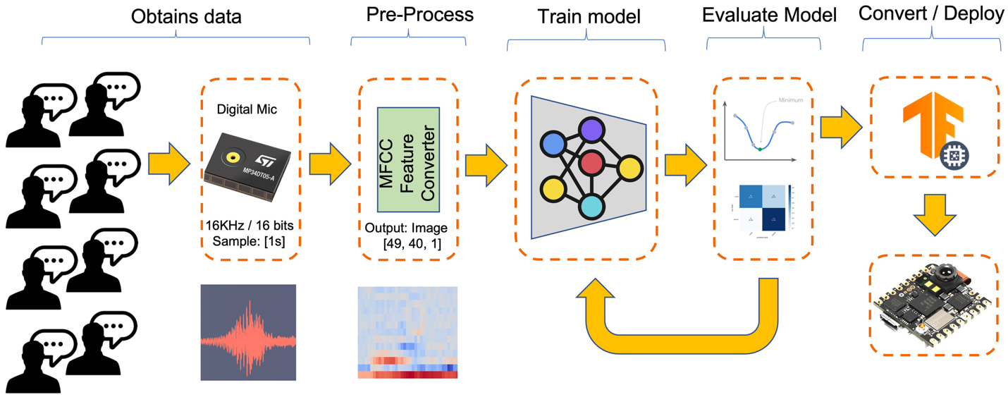

Dataset
The critical component of any Machine Learning Workflow is the dataset. You can download the dataset from Edge Studio (Keyword spotting pre-built dataset), which includes samples from the 3 classes we will use in this project: helloworld, noise, and background.
We can also take advantage of the dataset developed by Pete Warden, “Speech Commands: A Dataset for Limited-Vocabulary Speech Recognition.” This dataset has 35 keywords (with +1,000 samples each), such as yes, no, stop, and go. In words such as yes and no, we can get 1,500 samples.

Edge Impulse Studio
Edge Impulse Studio is a web-based platform for building, training, and deploying machine learning models to edge devices using your own data for specific tasks. It features an intuitive browser interface and also supports interaction through many developer tools, including APIs, CLIs, and libraries such as the Python SDK.
- Create an Edge Impulse account.
- click the Target (Top Right) to change the Target device to Arduino Nano 33 BLE Sense
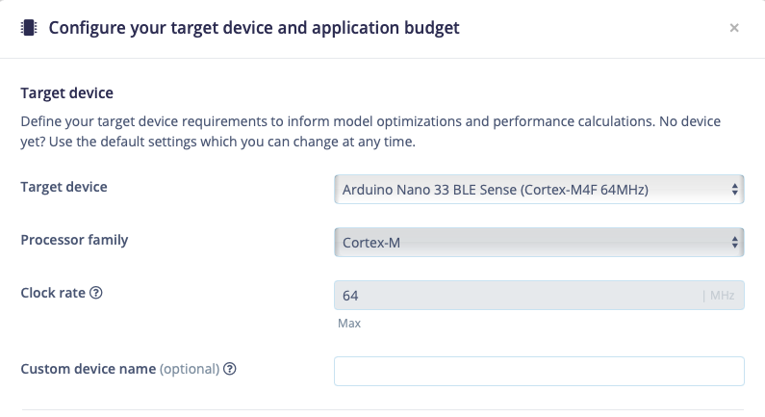
3. (Optional) Edge Impulse CLI
The Edge Impulse CLI is used to control local devices, act as a proxy to synchronise data for devices that don’t have an internet connection, and to upload and convert local files. For this lab, this part of the tool is unnecessarily.

Uploading the dataset to the Edge Impulse Studio
Initiate a new project at Edge Impulse Studio (EIS) and select the Add data button-> Upload data in the Data Acquisition section. Choose the folder to be uploaded:
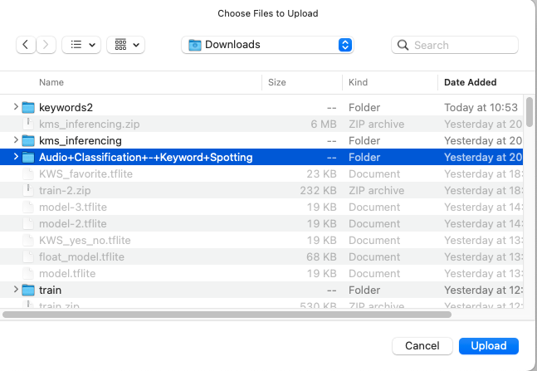
This dataset has been labeled. For other dataset, you might also need to label the data when uploading.
The dataset will now appear in the Data acquisition section.
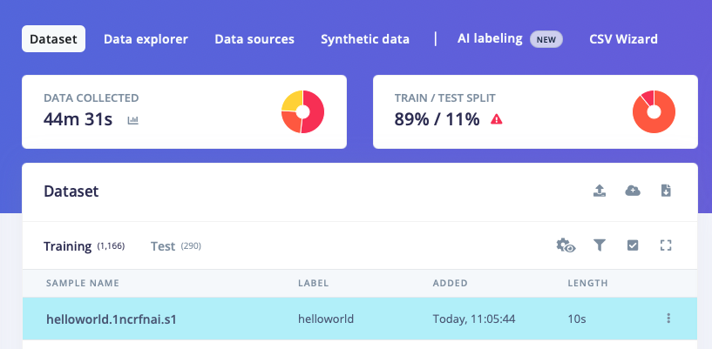

Click the red triangle mark to balance the train/test split. Click the Perform train / test split.
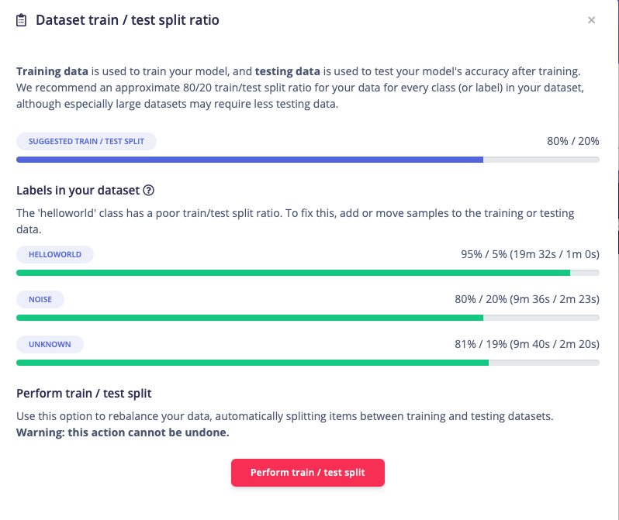

Capturing additional Audio Data
You could also connect a device to start building your own custom dataset.
And You can also use your PC or smartphone to capture audio data, using a sampling frequency of 16 KHz and a bit depth of 16.
Go to Devices, scan the QR Code using your phone, and click on the link. A data Collection app will appear in your browser. Select Collecting Audio, and define your Label, data capture Length, and Category.

Designing your impulse
With the data set in place you can design an impulse. An impulse takes the raw data, slices it up in smaller windows, uses signal processing blocks to extract features, and then uses a learning block to classify new data. Signal processing blocks always return the same values for the same input and are used to make raw data easier to process, while learning blocks learn from past experiences.
For this tutorial we’ll use the “MFCC” signal processing block. MFCC stands for Mel Frequency Cepstral Coefficients. This sounds scary, but it’s basically just a way of turning raw audio—which contains a large amount of redundant information—into simplified form. Edge Impulse has many other processing blocks for audio, including “MFE” and the “Spectrogram” blocks for non-voice audio, but the “MFCC” block is great for dealing with human speech.
We’ll then pass this simplified audio data into a Neural Network block, which will learn to distinguish between the three classes of audio. In the Studio, go to the Create impulse tab, add a Time series data, an Audio (MFCC) and a Classification (Keras) block. Leave the window size to 1 second (as that’s the length of our audio samples in the dataset) and click Save Impulse.
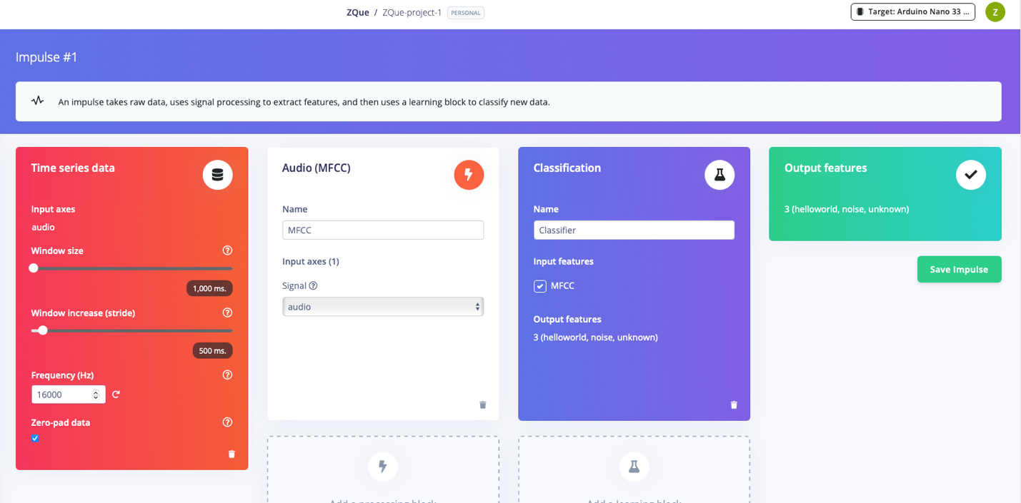

Configure the MFCC block
Now that we’ve assembled the building blocks of our Impulse, we can configure each individual part. Click on the MFCC tab in the left hand navigation menu. You’ll see a page that looks like this:
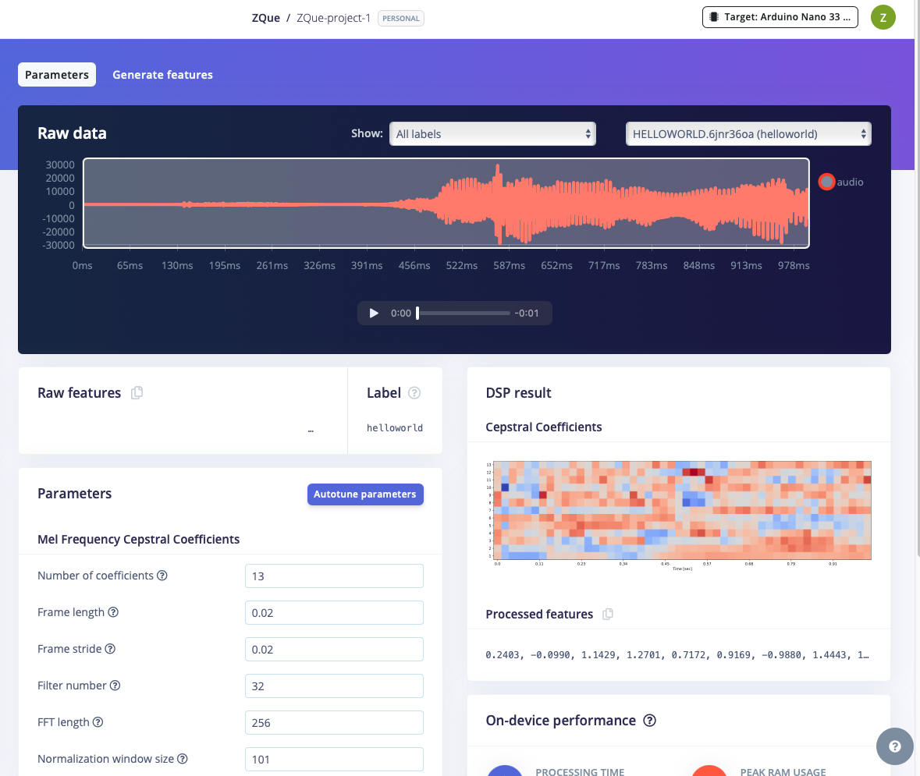
This page allows you to configure the MFCC block, and lets you preview how the data will be transformed. The right of the page shows a visualization of the MFCC’s output for a piece of audio, which is known as a spectrogram. An MFCC spectrogram is a specially tuned spectrogram which highlights frequencies which are common in human speech (Edge Impulse also has normal spectrograms if that’s more your thing).
In the spectrogram the vertical axis represents the frequencies (the number of frequency bands is controlled by ‘Number of coefficients’ parameter, try it out!), and the horizontal axis represents time (controlled by ‘frame stride’ and ‘frame length’). The patterns visible in a spectrogram contain information about what type of sound it represents.
It’s interesting to explore your data and look at the types of spectrograms it results in. You can use the dropdown box near the top right of the page to choose between different audio samples to visualize, or play with the parameters to see how the spectrogram changes.
In addition, you can see the performance of the MFCC block on your microcontroller below the spectrogram. This is the complete time that it takes on a low-power microcontroller (Arduino Nano 33 BLE) to analyze 1 second of data.
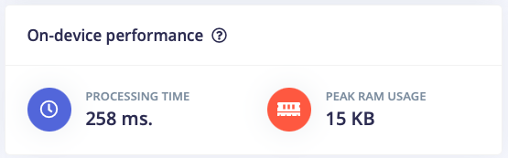

Feature explorer
The spectrograms generated by the MFCC block will be passed into a neural network architecture that is particularly good at learning to recognize patterns in this type of tabular data. Before training our neural network, we’ll need to generate MFCC blocks for all of our windows of audio. To do this, click the Generate features button at the top of the page, then click the green Generate features button. This will take a minute or so to complete.
Afterwards you’re presented with one of the most useful features in Edge Impulse: the feature explorer. It shows your complete dataset, with each data-item color-coded to its respective label. You can zoom in to every item, find anomalies (an item that’s in a wrong cluster), and click on items to listen to the sample. This is a great way to check whether your dataset contains wrong items, and to validate whether your dataset is suitable for ML (it should separate nicely).
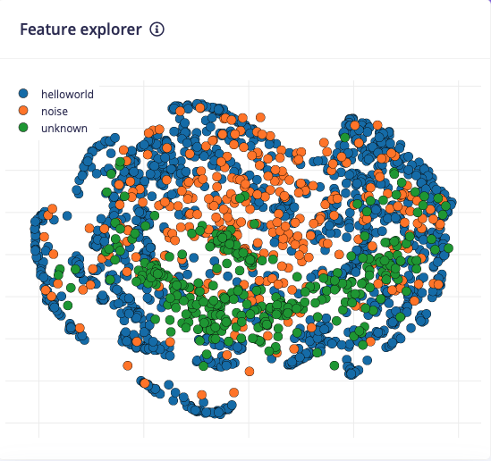

Configure the neural network
With all data processed it’s time to start training a neural network. Neural networks are algorithms, modeled loosely after the human brain, that can learn to recognize patterns that appear in their training data. The network that we’re training here will take the MFCC as an input, and try to map this to one of three classes—your keyword, noise or unknown.
Click on Classifier in the left hand menu. You’ll see the following page:
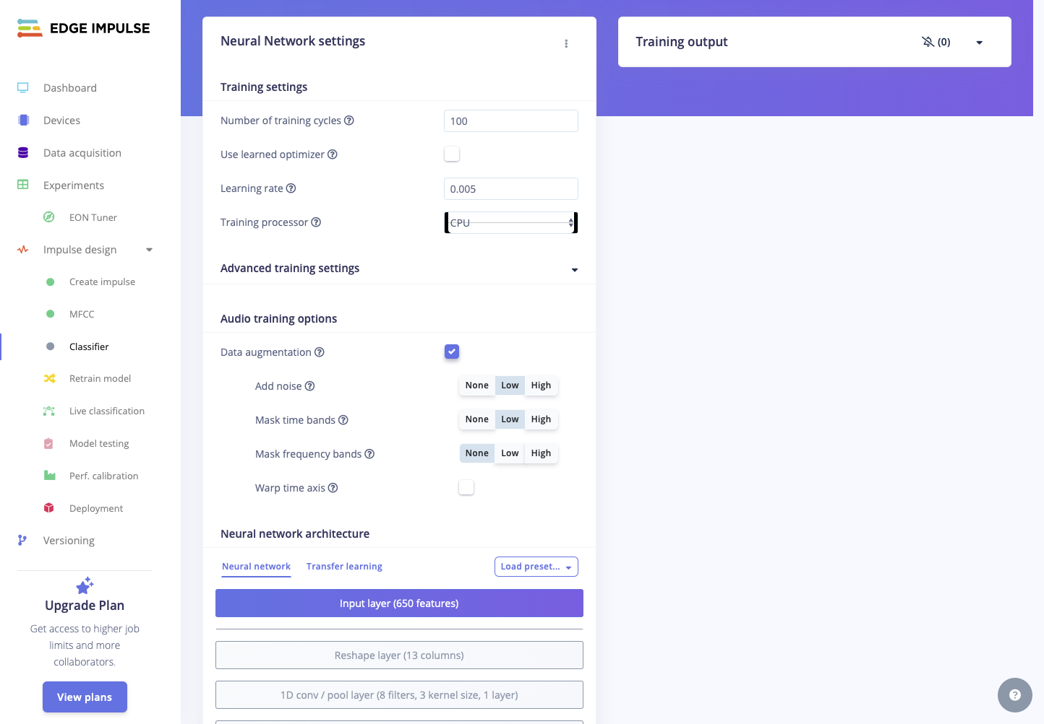
A neural network is composed of layers of virtual “neurons”, which you can see represented on the left hand side of the NN Classifier page. An input —in our case, an MFCC spectrogram—is fed into the first layer of neurons, which filters and transforms it based on each neuron’s unique internal state. The first layer’s output is then fed into the second layer, and so on, gradually transforming the original input into something radically different. In this case, the spectrogram input is transformed over four intermediate layers into just two numbers: the probability that the input represents your keyword, and the probability that the input represents ‘noise’ or ‘unknown’.
During training, the internal state of the neurons is gradually tweaked and refined so that the network transforms its input in just the right ways to produce the correct output. This is done by feeding in a sample of training data, checking how far the network’s output is from the correct answer, and adjusting the neurons’ internal state to make it more likely that a correct answer is produced next time. When done thousands of times, this results in a trained network.
A particular arrangement of layers is referred to as an architecture, and different architectures are useful for different tasks. The default neural network architecture provided by Edge Impulse will work well for our current project, but you can also define your own architectures. You can even import custom neural network code from tools used by data scientists, such as TensorFlow and Keras (click the three dots at the top of the page).
Next, enable ‘Data augmentation’. When enabled your data is randomly mutated during training. For example, by adding noise, masking time or frequency bands, or warping your time axis. This is a very quick way to make your dataset work better in real life (with unpredictable sounds coming in), and prevents your neural network from overfitting (as the data samples are changed every training cycle).
With everything in place, click Save & Train. You’ll see a lot of text flying past in the Training output panel, which you can ignore for now. Training will take a few minutes. When it’s complete, you’ll see the Last training performance panel appear at the bottom of the page:

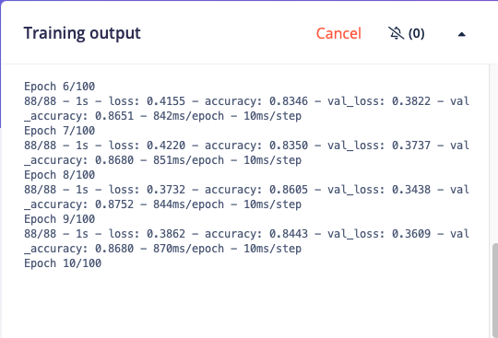
On the left hand side of the panel, Accuracy refers to the percentage of windows of audio that were correctly classified. The higher number the better, although an accuracy approaching 100% is unlikely, and is often a sign that your model has overfit the training data. You will find out whether this is true in the next stage, during model testing. For many applications, an accuracy above 85% can be considered very good.
The Confusion matrix is a table showing the balance of correctly versus incorrectly classified windows. The On-device performance region shows statistics about how the model is likely to run on-device.

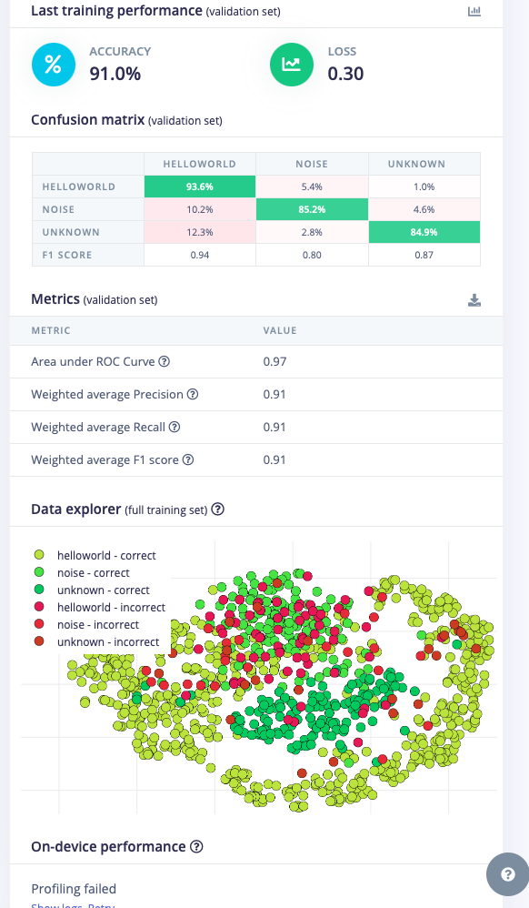

Analysis the model (Optional)
If you want to understand what is happening “under the hood,” you can download the pre-processed dataset (MFCC training data) from the Dashboard tab and run this Jupyter Notebook, playing with the code. For example, you can analyze the accuracy by each epoch:

Classifying new data
The performance numbers in the previous step show that our model is working well on its training data, but it’s extremely important that we test the model on new, unseen data before deploying it in the real world. This will help us ensure the model has not learned to overfit the training data, which is a common occurrence.
Fortunately we’ve put aside 20% of our data already in the ‘Test set’ (see Data acquisition). This is data that the model has never seen before, and we can use this to validate whether our model actually works on unseen data. To run your model against the test set, head to Model testing, and click Classify selected.
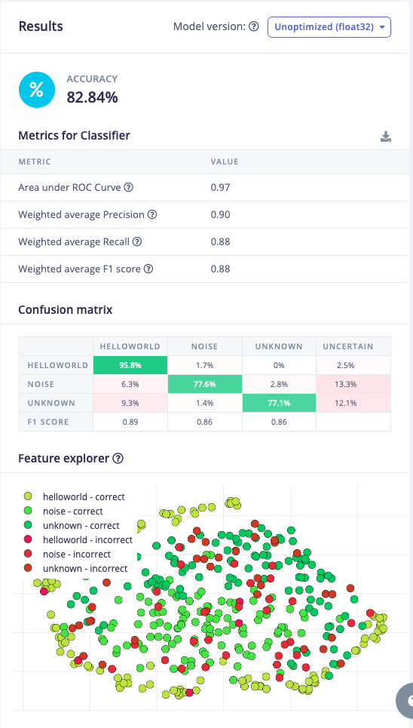

To drill down into a misclassified sample, click the three dots (⋮) next to a sample and select Show classification. You’re then transported to the classification view, which lets you inspect the sample, and compare the sample to your training data. This way you can inspect whether this was actually a classification failure, or whether your data was incorrectly labeled. From here you can either update the label (when the label was wrong), or move the item to the training set to refine your model.
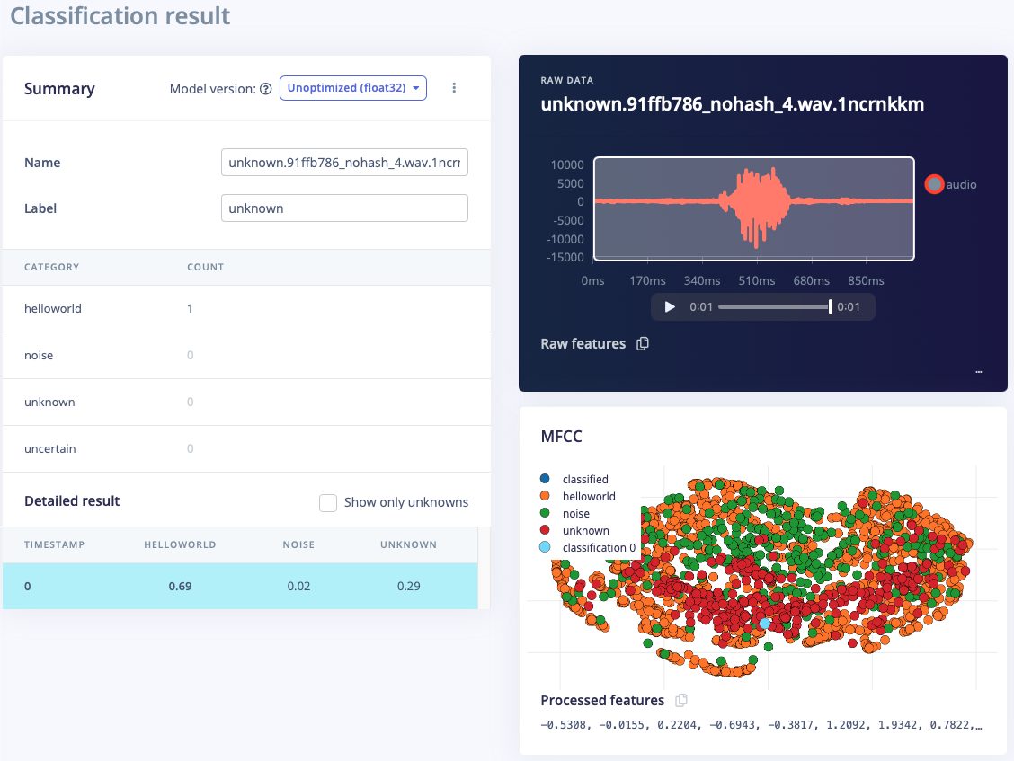

Deploying to your device
With the impulse designed, trained and verified you can deploy this model back to your device. This makes the model run without an internet connection, minimizes latency, and runs with minimum power consumption. Edge Impulse can package up the complete impulse - including the MFCC algorithm, neural network weights, and classification code - in a single C++ library that you can include in your embedded software.
To export your model, click on Deployment in the menu. Then under ‘Build firmware’ select your development board (Arduino Library), and click Build. This will export the impulse, and build a binary that will run on your development board in a single step. After building is completed you’ll get prompted to download a binary. Save this on your computer.
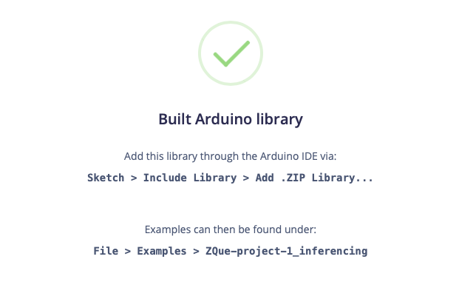
Please note that the project name may be different.
In the Arduino IDE, you could open nano_ble33_sense_microphone or nano_ble33_sense_microphone_continuous
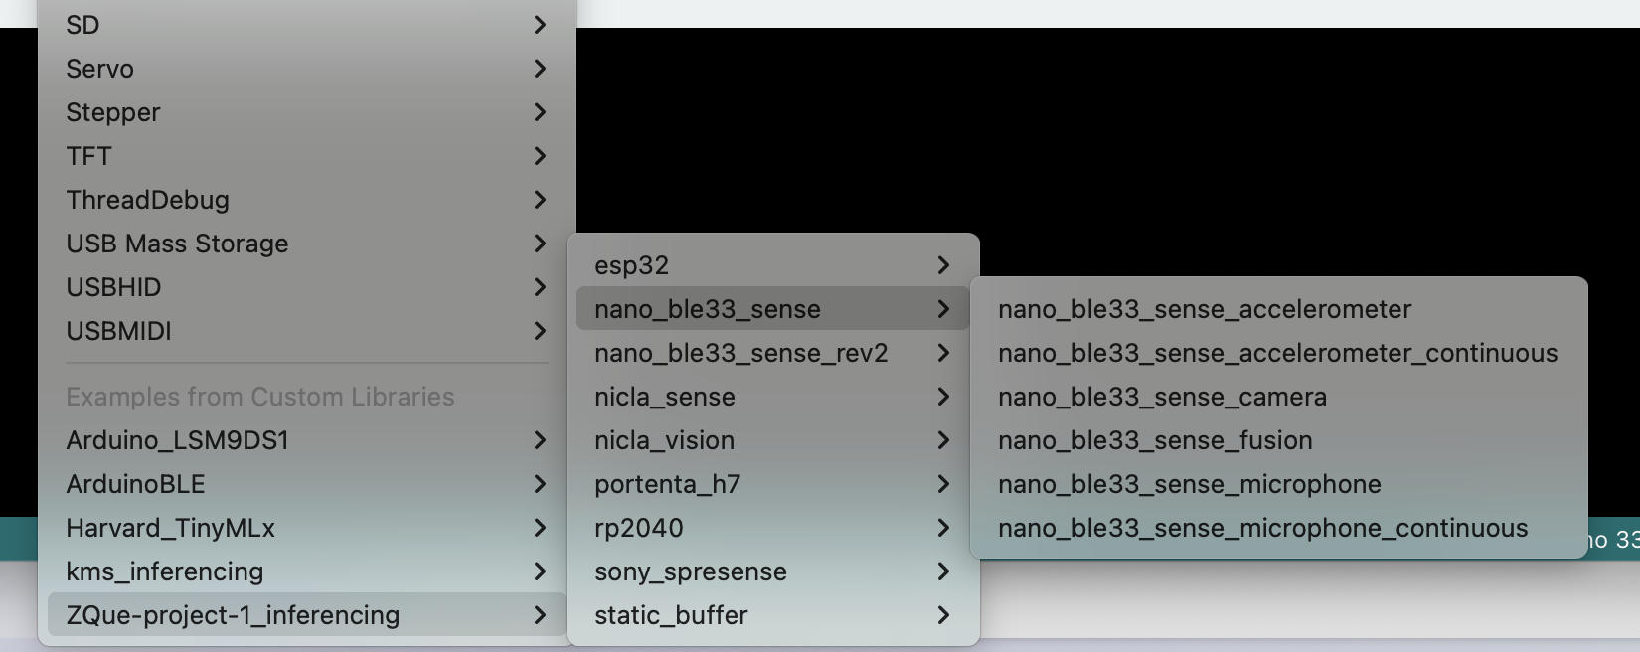
The message below shows it detects the helloworld.
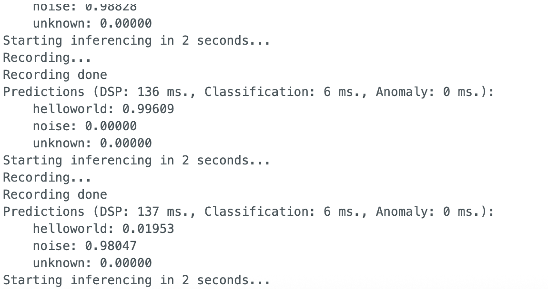

Thanks to Prof. Marcelo Rovai and the ML Systems open book, as well as the KWS example on edge impulse website

Optional Tasks,
- in "Configure the neural network", select a new model, or add a few more layers, and try again
- explore the anomaly audios.
- Now that we know the model is working since it detects our keywords. Is it possible to see the result with the Arduino completely offline (disconnected from the PC and powered by a battery, a power bank, or an independent 5V power supply)? The idea is that whenever the keyword Helloworld is detected, the LED will blink.

